**Experiment No.: 9**

**Aim:** Shell script to display your name.

**Procedure :**

#!/bin/bash

echo “Enter your Name “

read name

echo “Your name is $name”

**Output**

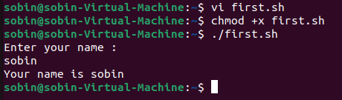

**Experiment No.: 10**

**Aim:** Shell script to display date.

**Procedure**

#!/bin/bash

date

**Output**

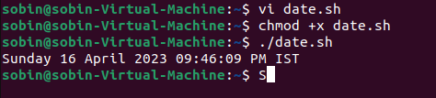

**Experiment No.:11**

**Aim:**Shell script to display pwd,ls,date commands .

**Procedure**

#!/bin/bash

date

ls

pwd

mkdir file1

**Output**

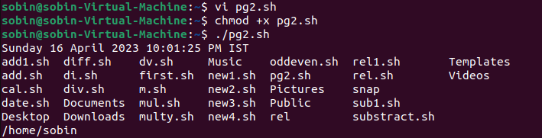

**Experiment No.: 12**

**Aim:** Shell script to demonstrate variables.

**Procedure**

#!/bin/bash

echo "filename: $0"

echo "first parameter : $1"

echo "second parameter: $2"

echo "quoted values: $@"

echo "quoted values: $*"

echo "process number: $$"

echo "exist status: $?"

echo "process number of last background command: $!"

echo "total no of parameters: $#"

**Output**

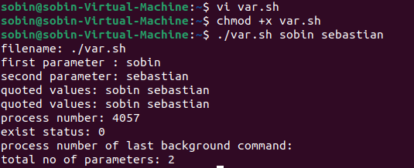

**Experiment No.: 14**

**Aim:** Shell script to count words and lines in a file.

**Procedure**

#!/bin/bash

filepath="/home/sobin/f1.txt"

countlines=`wc --line < $filepath`

countword=`wc --word < $filepath`

echo "no of lines: $countlines"

echo "no of words: $countword"

**Output**

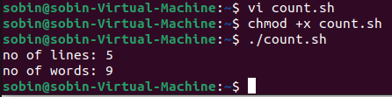

**Experiment No.: 15**

**Aim:** Shell script to display array index.

**Procedure**

#!/bin/bash

name[0]="sobin sebastian"

echo "first index: ${name[0]}"

**Output**

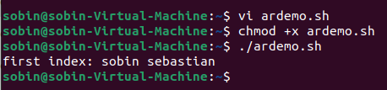

**Experiment No.: 16**

**Aim:** Shell script to demonstrate Arithmetic operations.

**Procedure**

#!/bin/bash

read -p "Enter a: " a

read -p "Enter b: " b

add=$(( a + b ))

echo "addition of a and b are: $add"

sub=$(( a - b))

echo "subtraction of a and b are: $sub"

mul=$(( a * b))

echo "multiplication of a and b are: $mul"

div=$(( a / b ))

echo "division of and b are: $div"

mod=$(( a%b))

echo "modules of a and b are $mod"

if [ $a == $b ]

then

echo "a is equal to b"

fi

if [ $a != $b ]

then

echo "a is not equal to b"

fi

a=$(( ++a ))

echo "increment operator on a $a"

b=$(( --b ))

echo "decrement operator on b $b"

**Output**

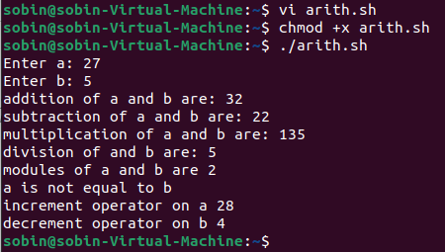

**Experiment No.: 17**

**Aim:** Shell script to demonstrate Relational operations.

**Procedure**

#!/bin/bash

read -p "Enter THE a" a

read -p "Enter b " b

if (( $a == $b ))

then

echo "a is equal to b "

else

echo "a not is equal to b "

fi

if (( $a != $b ))

then

echo "a is  not equal to b "

else

echo "a is equal to b "

fi

if (( $a < $b ))

then

echo "a is less than b "

else

echo "a is not less than  b "

fi

if (( $a <= $b ))

then

echo "a is less than / equal to b "

else

echo "a is not less than / equal to b "

fi

if (( $a > $b ))

then

echo "a is greater than  b "

else

echo "a is not greater  b "

fi

if (( $a >= $b ))

then

echo "a is greater than/equal to  b "

else

echo "a is not graeter tha/equal to b "

fi

**Output**

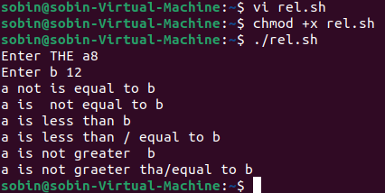

**Experiment No.: 18**

**Aim:** Shell script to check whether a number is odd or even.

**Procedure**

#!/bin/bash

read -p "Enter the number:" num

if(( $num % 2 == 0))

then

echo the number is even

else

echo the number is odd

fi

**Output**

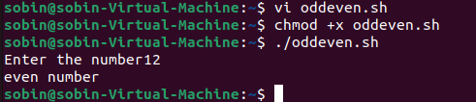

**Experiment No.: 19**

**Aim:** Shell script to demonstrate Boolean operations**.**

**Procedure**

read -p 'Enter a : ' a

read -p 'Enter b : ' b

if(($a == "true" & $b == "true" ))

then

    echo Both are true.

else

    echo Both are not true.

fi

if(($a == "true" || $b == "true" ))

then

    echo Atleast one of them is true.

else

    echo None of them is true.

fi

if(( ! $a == "true"  ))

then

    echo "a" was initially false.

else

     echo "a" was initially true.

 fi

**Output**

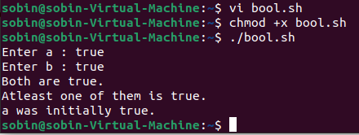

**Experiment No.: 20**

**Aim:**Shell script to find the greatest of three numbers .

**Procedure**

echo "Enter Num1"

read num1

echo "Enter Num2"

read num2

echo "Enter Num3"

read num3

if [ $num1 -gt $num2 ] && [ $num1 -gt $num3 ]

then

    echo $num1

elif [ $num2 -gt $num1 ] && [ $num2 -gt $num3 ]

then

    echo $num2

else

    echo $num3

fi

**Output**

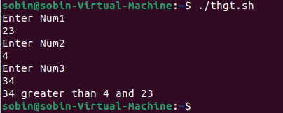

**Experiment No.: 21**

**Aim:** Shell script to demonstrate String operations.

**Procedure**

#!/bin/sh

read -p “Enter the frist string : ” a

read -p “Enter the second string: “ b

if [ $a = $b ]

then

   echo "$a = $b : a is equal to b"

else

   echo "$a = $b: a is not equal to b"

fi

if [ $a != $b ]

then

   echo "$a != $b : a is not equal to b"

else

   echo "$a != $b: a is equal to b"

fi

if [ -z $a ]

then

   echo "-z $a : string length is zero"

else

   echo "-z $a : string length is not zero"

fi

if [ -n $a ]

then

   echo "-n $a : string length is not zero"

else

   echo "-n $a : string length is zero"

fi

if [ $a ]

then

   echo "$a : string is not empty"

else

   echo "$a : string is empty"

fi

**Output**

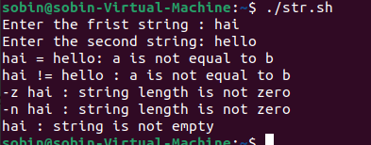

**Experiment No.: 22**

**Aim:**Shell script to demonstrate bitwise operations.

**Procedure**

read -p 'Enter a : ' a

read -p 'Enter b : ' b

bitwiseAND=$(( a&b ))

echo Bitwise AND of a and b is $bitwiseAND

bitwiseOR=$(( a|b ))

echo Bitwise OR of a and b is $bitwiseOR

bitwiseXOR=$(( a^b ))

echo Bitwise XOR of a and b is $bitwiseXOR

bitiwiseComplement=$(( ~a ))

echo Bitwise Compliment of a is $bitiwiseComplement

leftshift=$(( a<<1 ))

echo Left Shift of a is $leftshift

rightshift=$(( b>>1 ))

echo Right Shift of b is $rightshift

**Output**

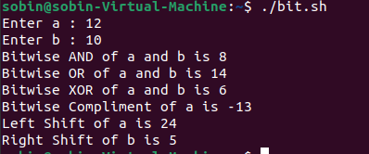

**Experiment No.: 23**

**Aim:** Shell script to demonstrate file test methods.

**Procedure**

read -p 'Enter file name : ' FileName

if [ -e $FileName ]

then

    echo File Exist

else

    echo File doesnot exist

fi

if [ -s $FileName ]

then

    echo The given file is not empty.

else

    echo The given file is empty.

fi

if [ -r $FileName ]

then

    echo The given file has read access.

else

    echo The given file does not has read access.

fi

if [ -w $FileName ]

then

    echo The given file has write access.

else

    echo The given file does not has write access.

fi

if [ -x $FileName ]

then

    echo The given file has execute access.

else

    echo The given file does not has execute access.

fi

**Output**

